Ideation Phase Empathize & Discover

Date | 27 JUNE 2025
NM ID | 8050612605B5D909A0D43F9BC95E1D9A
Project Name | Garage Management system
Maximum Marks | 4 Marks

Empathy Map Canvas:
In the Empathize & Discover phase, the team observes how admins and managers handle user deletions in the system. They learn that many users feel frustrated when they can’t delete accounts because of hidden incident assignments. By interviewing stakeholders, they uncover that this issue causes delays, confusion, and extra work to track down which incidents are still linked to the user.
Gathering these insights helps the team see the real impact on workflows and data integrity. Understanding the users’ daily challenges makes it clear that better guidance, alerts, and automated checks are needed. These discoveries will shape solutions that are practical and user-friendly.

Example:

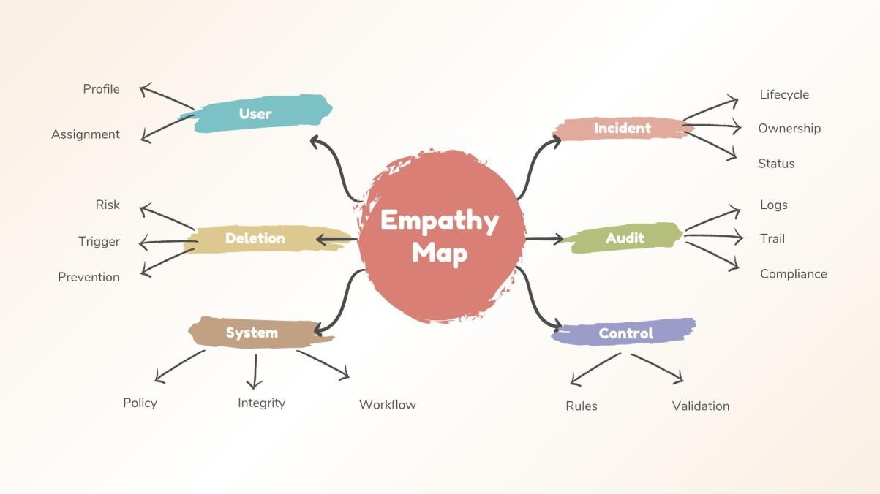

Reference: https://www.mural.co/templates/empathy-map-canvas

The empathy map helped us understand user challenges when deleting assigned users. It shows their pain, actions, and needs for better control and alerts. This guided us to design a safer system that prevents accidental deletion.

Example: Food Ordering & Delivery Application
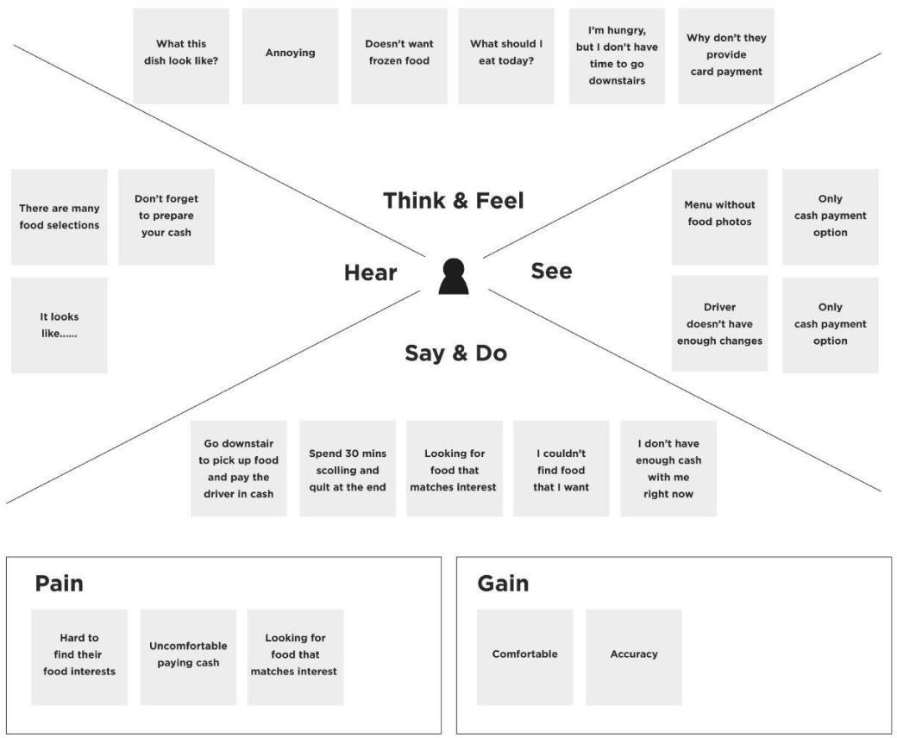

By deeply understanding the users through empathy mapping, we identified the critical risks and frustrations associated with the accidental deletion of users assigned to incidents. These insights revealed pain points such as lack of real-time alerts, unclear user- assignment visibility, and absence of system safeguards. As a result, we designed a more intelligent and secure system in ServiceNow that integrates validation checks, confirmation prompts, and real-time assignment tracking. This ensures that no user tied to an active incident can be deleted unintentionally, thereby improving accountability, boosting system reliability, and enhancing user confidence in incident management processes.

